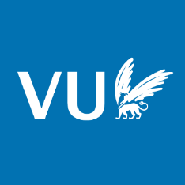
Training for 3rd and 4th year PhD Candidates

Programme
April 8, 2026
Location: Vrije Universiteit Amsterdam, Initium building, De Boelelaan 1077
Room: IN 2A-45/47
9.00-9.45 Registration with coffee/tea
9.45-10.00 Welcome (Bahija Aarrass, Jordan Dez, Tycho Scholten)
10.00-11.00 Career After PhD
Panel 1: Nelleke Koffeman, Coordinator human rights unit, Ministry of Justice & Security
Doutje Lettinga, Chief Science Officer, Municipality of Amsterdam
Isabella Leroy, Postdoc, Ghent Human Rights Centre
Jeremy Bierbach, Lawyer and Owner, Bierbach Advocaten
11.00-11.30 Coffee & tea break
11.30-12.30 Research funds & grants
Panel 2: Marco Last, Grants Specialist VU
Tim Bleeker, Associate Professor VU
Liberty Chee, Associate Scientific Editor, Elsevier
12.30-14.30 Lunch break
14.30-16.00 Publish or perish?
Panel 3: Katherin Fortin, Editor in Chief of the Netherlands Quarterly of Human Rights
Inge Klompmakers, Publisher at the Asser Institute
Jordan Dez, Assistant Professor VU
16.00 Closing
16.30 Drinks

